Notes

The identity vector from the top and bottom identical NNs are compared such that the same dimensions are compared with each other:

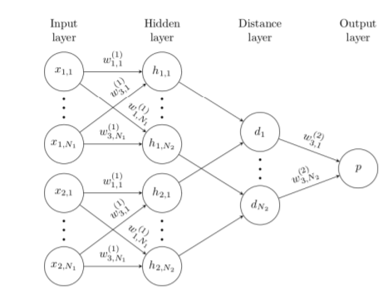

Weight tying can be achieved by adding the gradients from both identical neural networks.

The learning rate was decayed with the following formula: $η_{j}^{(T)}=0.99η_{j}^{(T-1)}$. The learning rate $η_{j}ϵ[{10}^{-4},{10}^{-1}]$.

The momentum started at 0.5 in every layer, increasing linearly each epoch until reaching the value $μ_{j}$, the individual momentum term for the jth layer. $μ_{j}ϵ[0,1]$.

“We trained each network for a maximum of 200 epochs, but monitored one-shot validation error on a set of 320 one-shot learning tasks [...]. When the validation error did not decrease for 20 epoches, we stopped and used the parameters of the model at the best epoch according to the one-shot validation error. If the validation error continued to decrease for the entire learning schedule, we saved the final state of the model generated by this procedure.”

$λ_{j}ϵ[0, 0.1]$.

References

* <https://www.cs.cmu.edu/~rsalakhu/papers/oneshot1.pdf>